**CPE 343 – Computer Organization & Architecture**



**Write here**

**Lab # 2**

**Title: Design the combinational circuit using conditional signal assignment in VHDL.**

|  |  |
| --- | --- |
| Name | Abdul Basit |
| Registration Number | FA17-BCE-062 |
| Class | FA17-BCE-B |
| Instructor’s Name | Moazzam Ali Sahi |

**INTRODUCTION:**

VHDL provides more than one method to implement same logic using different commands.

* Equations
* Truth-table

1. IF ELSE
2. When Statement

And to know about Arithmetic, assignment, logical and multiplying operators.

**LAB TASKS: (In-Lab Tasks)**

Implementation of Decoder 2x4. There are several ways to do it but the easiest one is by using when statement.

**Task 1:**

1. VHDL Code

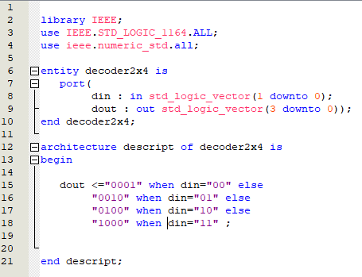

1. Results (VWF)

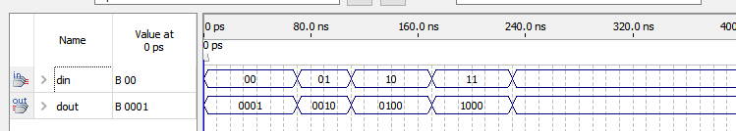

**Task 2:**

1. VHDL Code

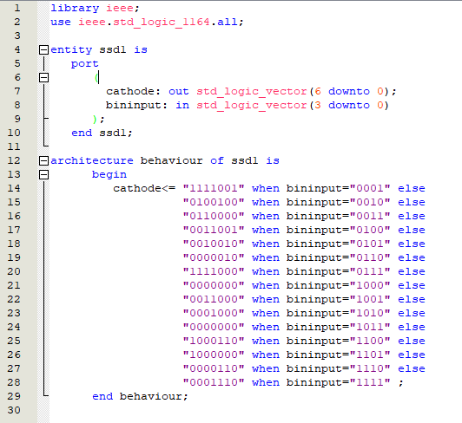

1. Results (VWF)

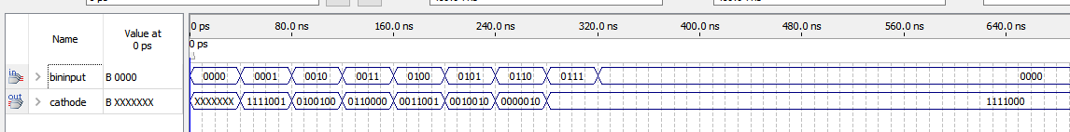

# CONCLUSION:

In this lab I learned how to use conditional statement for hardware coding. And created the decoder and seven segment display.